**GETTING STARTED WITH LINUX SYSTEM ADMINISTRATION**

**There is lot key system information is kept with in the virtual files in the /proc directory .**

**cd /proc**

**ls**

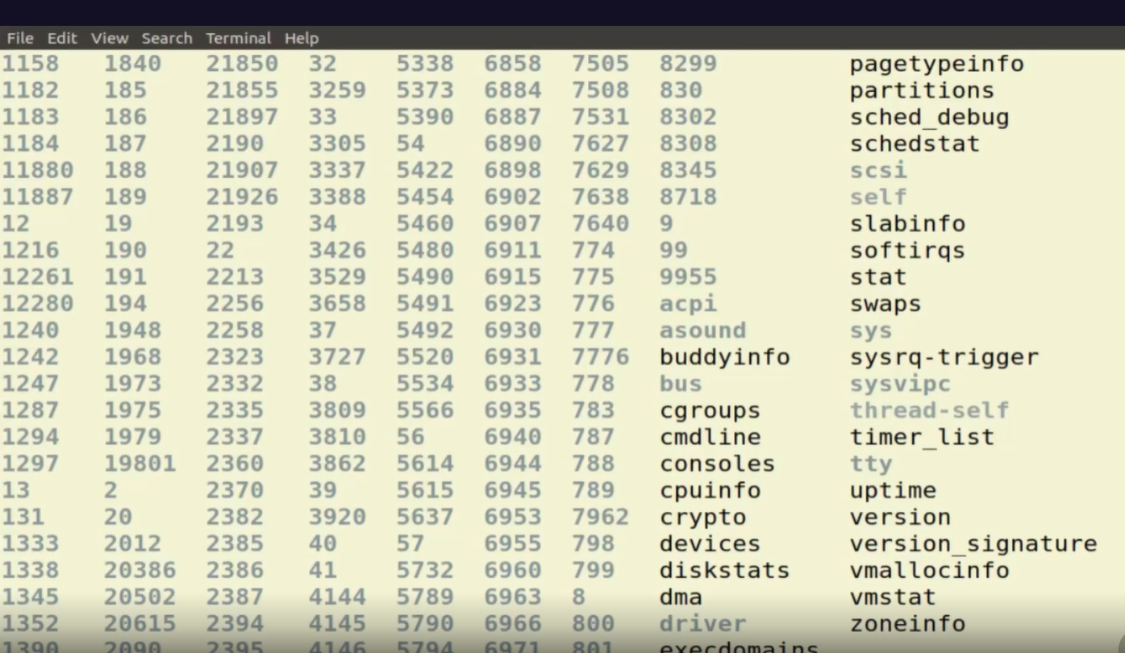

The files are virtual in the sense that they're not persistent, but are created dynamically with each system boot and in response to system events.

**less meminfo command displays follows:**

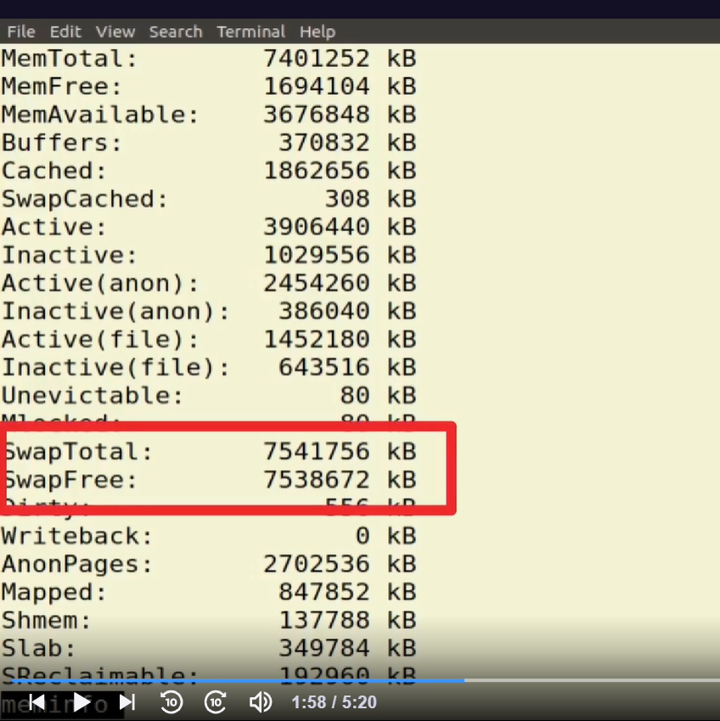

The meminfo file, for instance, contains information about the capacity and usage levels of your system memory. The output shows me how much physical memory I've got and how much of it is not currently being used. My swap memory is also displayed.

**less cpuinfo :**

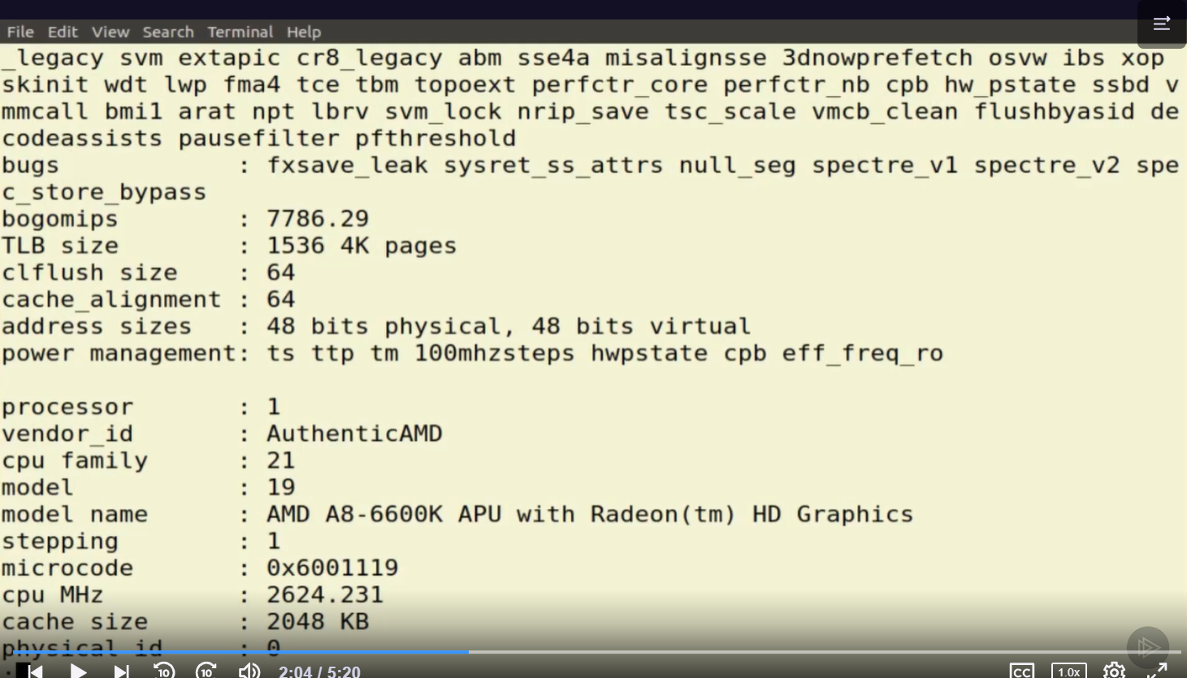

Cpuinfo tells me everything I could want to know about the capacity and specifications of the four CPU cores I've got on my system.

Top **top** (**t**able **o**f **p**rocesses) command

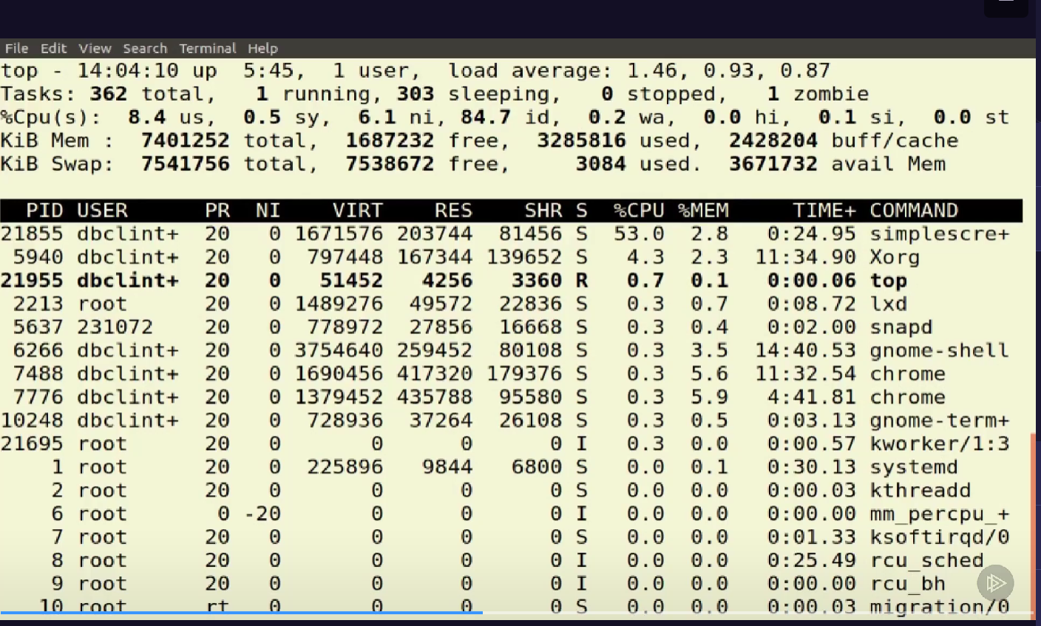

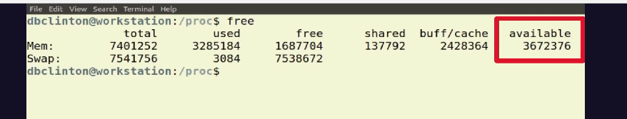

**free**command which displays the total amount of free space available along with the amount of memory used and swap memory in the system, and also the buffers used by the kernel.

Free -h : dispalys free space in actual size. H means human readable form.

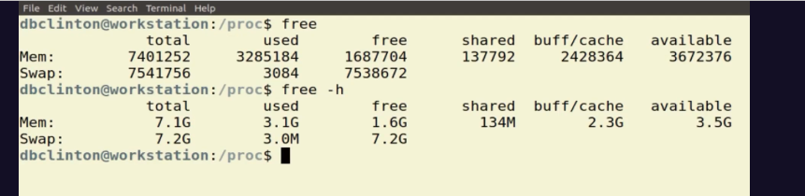

**df** command that displays the amount of disk space available on the file system containing each file name argument.

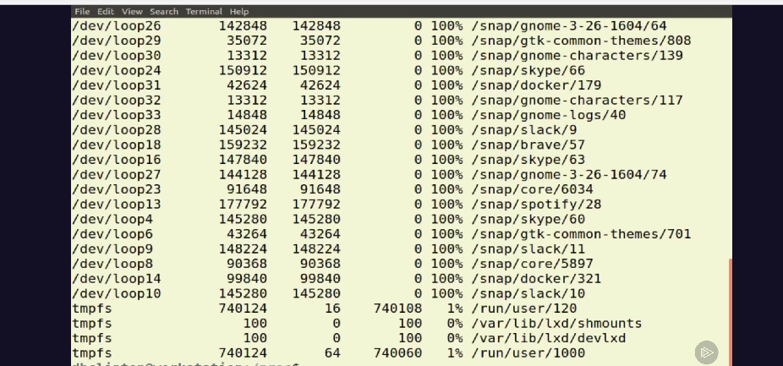

  df -t ext4 display content in ext4 file type

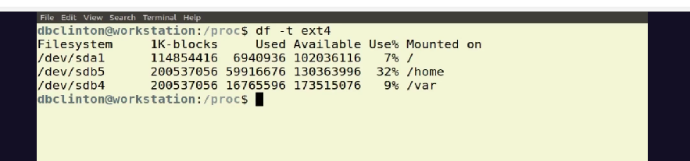

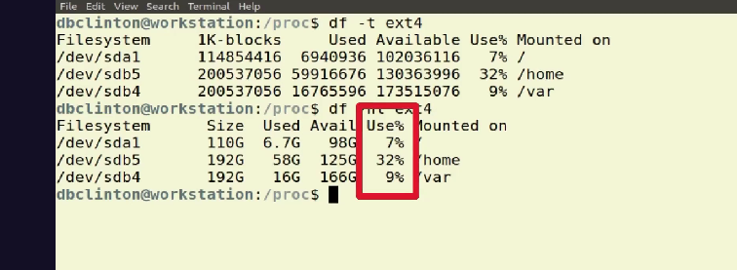

Above shows in human readable form.

Sudo apt update

It update the ubuntu.

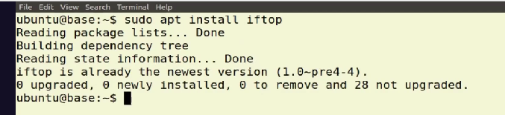

**iftop** is a network analyzing tool used by system administrators to view the bandwidth related stats. It shows a quick overview of the networking activities on an interface.

Refer: [iftop command in Linux with Examples - GeeksforGeeks](https://www.geeksforgeeks.org/iftop-command-in-linux-with-examples/)

Ip addr : will get private ip address of interface .

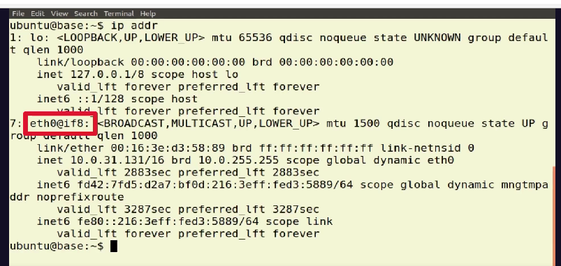

The active interface on this machine is eth0.

sudo iftop -i eth0

will display basic bandwidth usage of default interface .

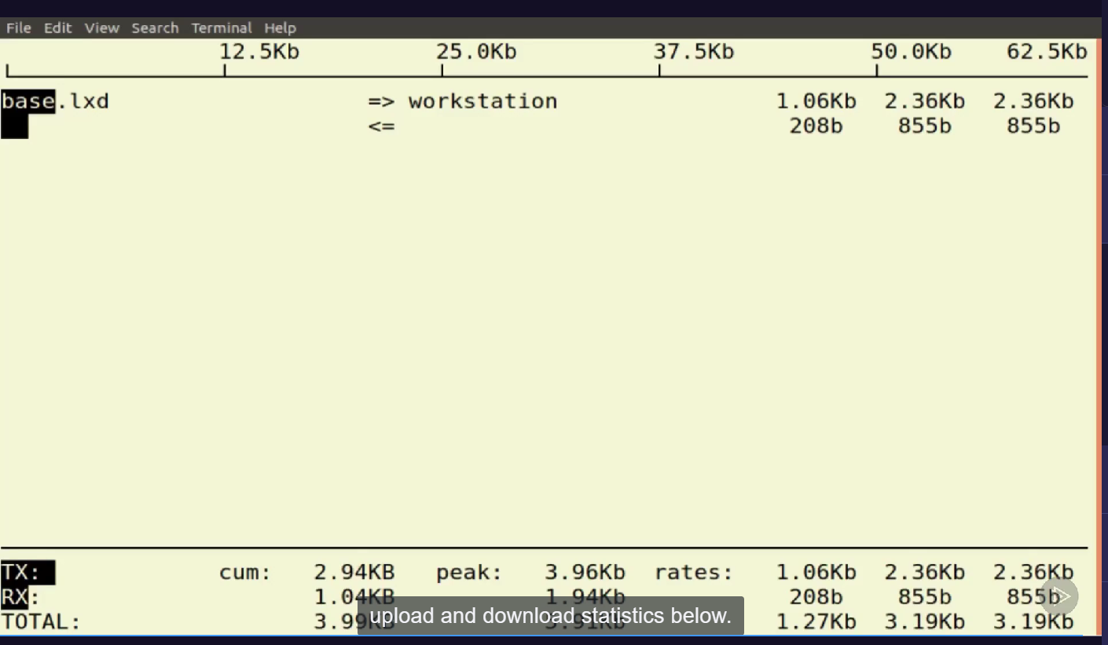

on a busy system you'd see source and target addresses associated with requests in the top section of the screen and upload and download statistics below. If there was a process making data‑heavy calls to a remote server, it would show up here.

**Managing System Processes**

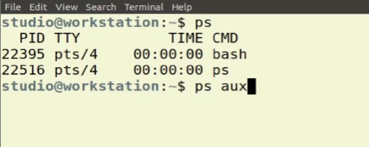

**ps** command writes the status of active process.

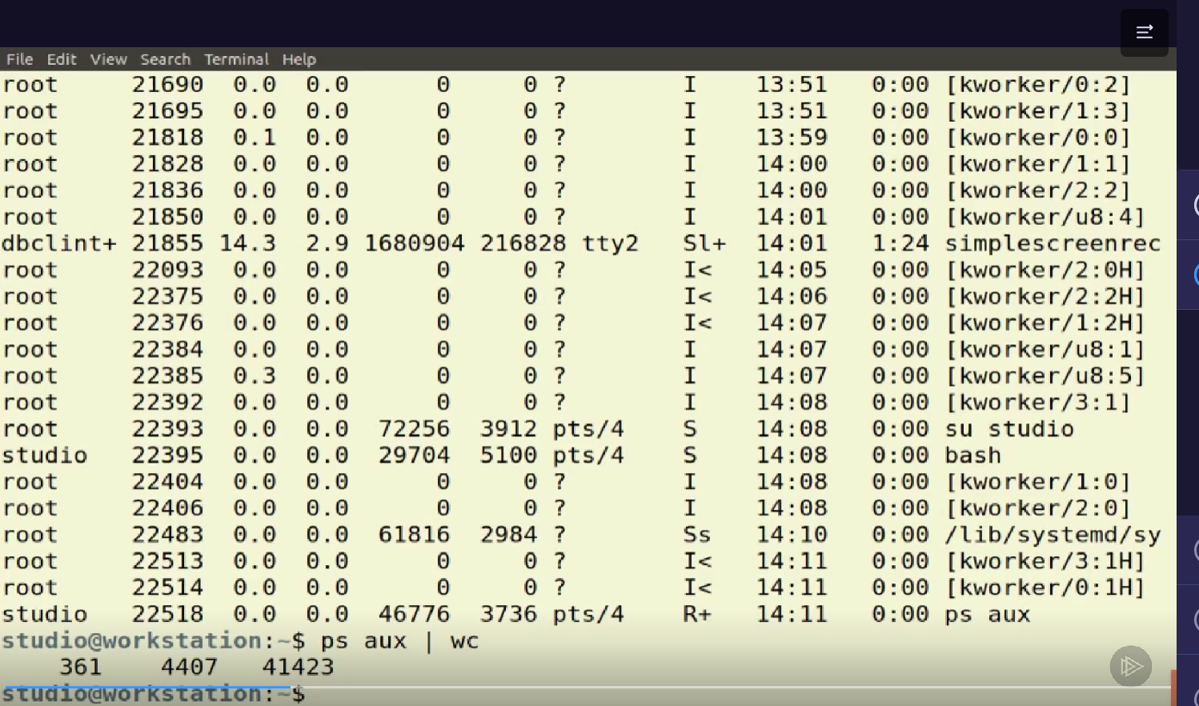

ps aux : display the information of all running processes.

Grep command

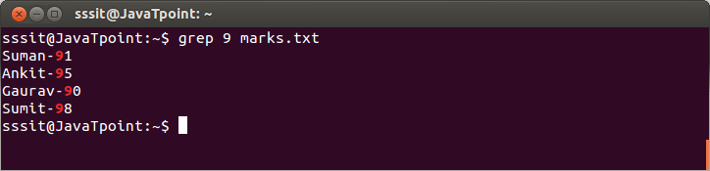

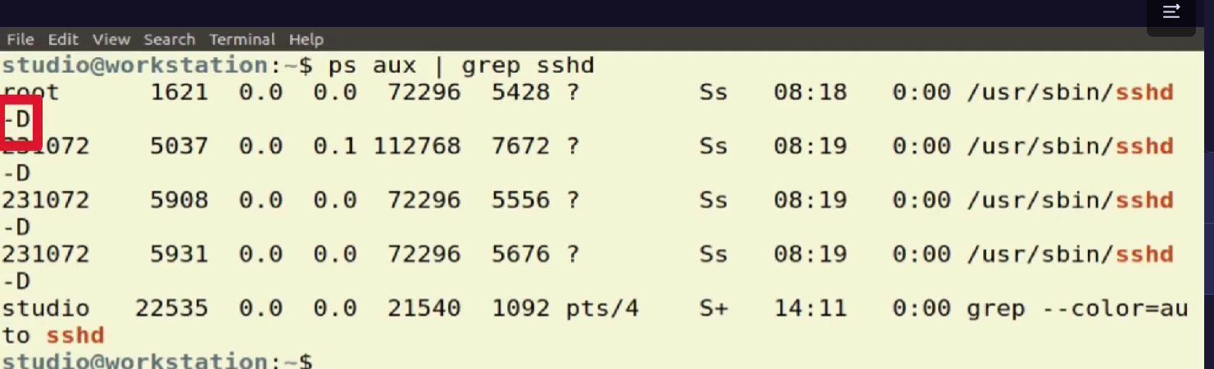

These are the precise folder to loanch the process .

The op of ps aux is given by pipeline (|) command to grep sshd

The grep command find the files matching tosshd keyword sshd .

**Man sshd**

man command in Linux is used to display the user manual of any command that we can run on the terminal. It provides a detailed view of the command which includes NAME, SYNOPSIS, DESCRIPTION, OPTIONS, EXIT STATUS, RETURN VALUES, ERRORS, FILES, VERSIONS, EXAMPLES, AUTHORS and SEE ALSO.

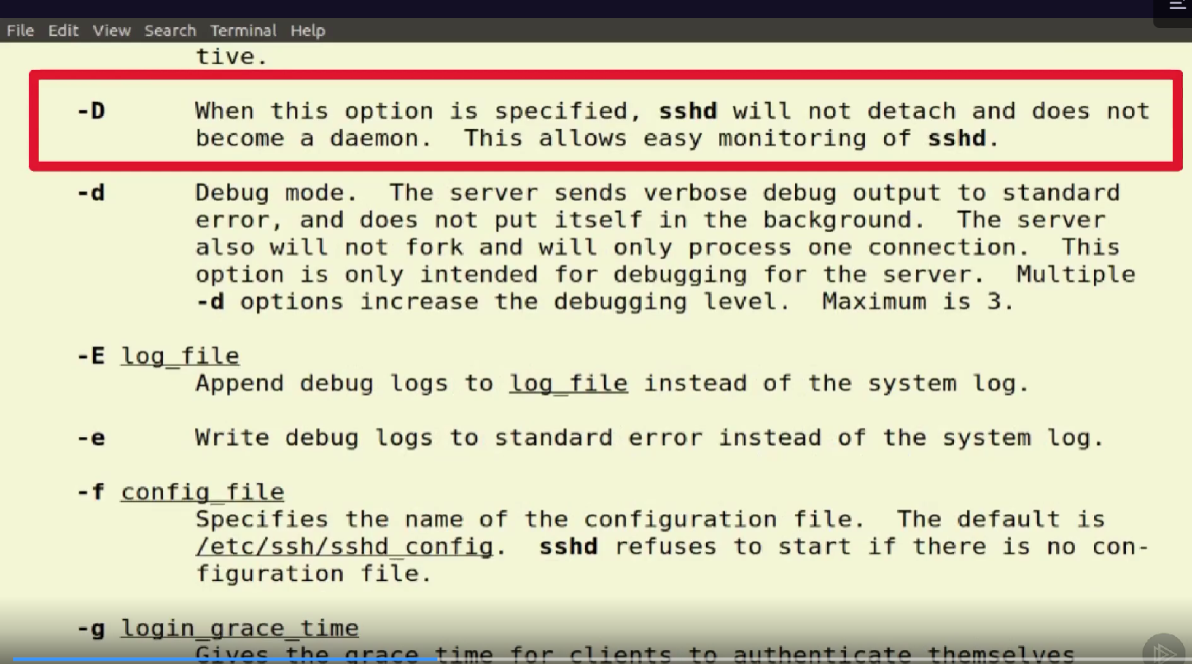

journalctl is the command line tool that lets you interact with the journal logs. You can filter logs for a certain time period and there are various ways to do that.

Eg :journalctl --since "2020-07-10"

The journal is a component of systemd. It's a centralized location for all messages logged by different components in a systemd-enabled Linux system. This includes kernel and boot messages, messages coming from syslog, or different services.

Systemd is a system and service manager for Linux, compatible with SysV and LSB init scripts. Systemd provides: Aggressive parallelization capabilities. Uses socket and D-Bus activation for starting services. Offers on-demand starting of daemons, keeps track of processes using Linux cgroups.

What is a journal log?

Logs, journals and diaries are monitoring tools for recording data over a long period of time.

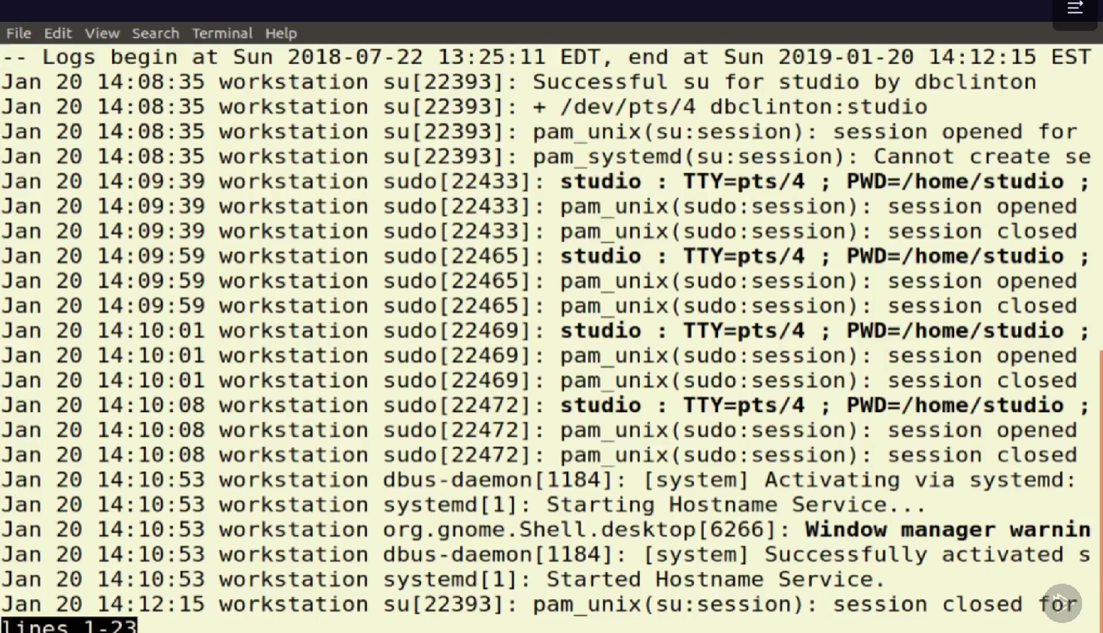

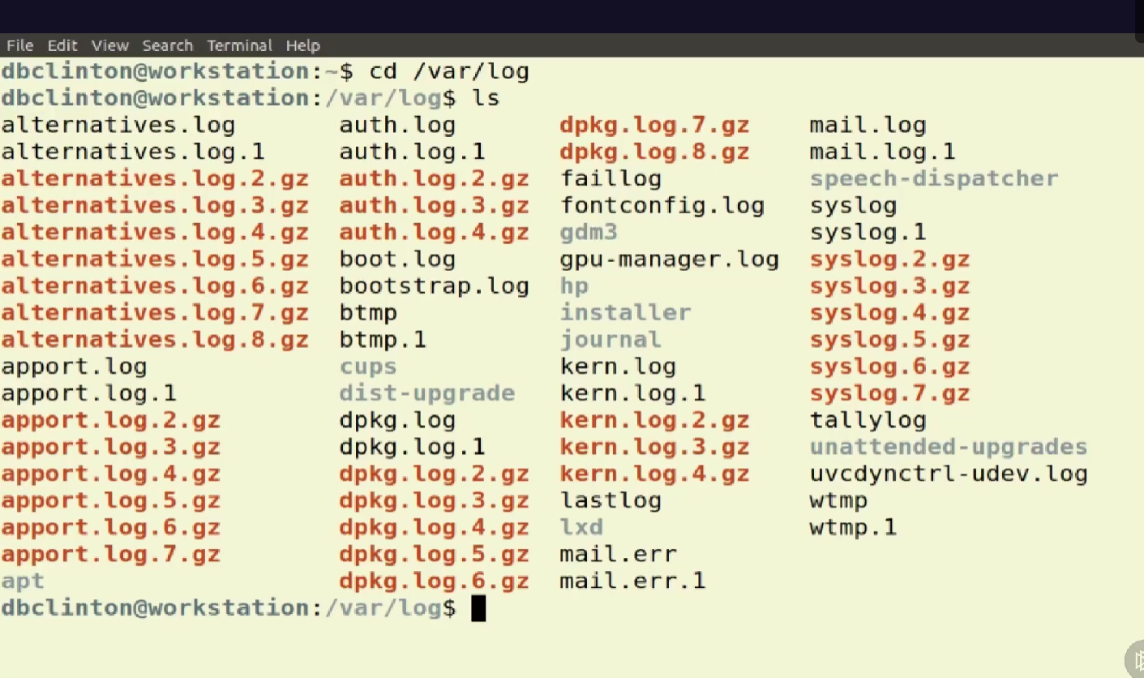

**dmesg Command**

The dmesg command is a Linux utility that displays kernel-related messages retrieved from the kernel ring buffer. The ring buffer stores information about hardware, device driver initialization, and messages from kernel modules that take place during system startup.

The Linux command is a utility of the Linux operating system.

The Linux® kernel is the main component of a [Linux operating system (OS)](https://www.redhat.com/en/topics/linux/what-is-linux) and is the core interface between a computer’s hardware and its processes. It communicates between the 2, managing resources as efficiently as possible.

The kernel is so named because—like a seed inside a hard shell—it exists within the OS and controls all the major functions of the hardware, whether it’s a phone, laptop, server, or any other kind of computer.

A process in Linux is nothing but a program in execution. It's a running instance of a program. Any command that you execute starts a process.

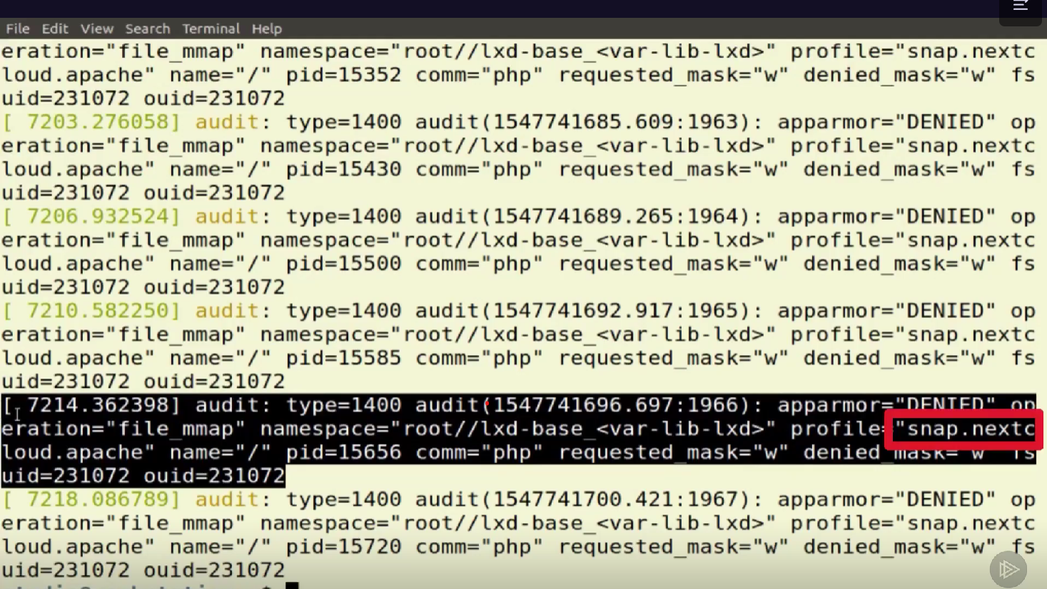

**Snap**

To see all installed packages: snap list. To get information about a single package: snap info package_name. To change the channel a package tracks for updates: sudo snap refresh package_name --channel=channel_name. To see whether updates are ready for any installed packages: sudo snap refresh --list.

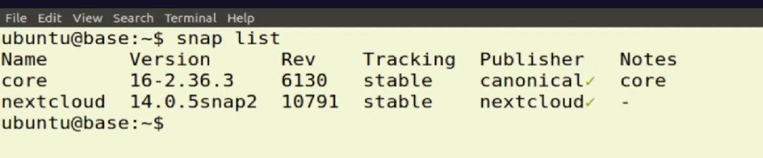

To keep a terminal session open indefinitely, we can use the yes command: $ yes > /dev/null & This sends the output to the null device and runs the command in the background, effectively discarding the output and keeping the terminal busy with a continuous stream of 'y' characters.

Refer: <https://www.howtogeek.com/415535/how-to-use-the-yes-command-on-linux/>

<https://linuxhint.com/what_is_dev_null/>

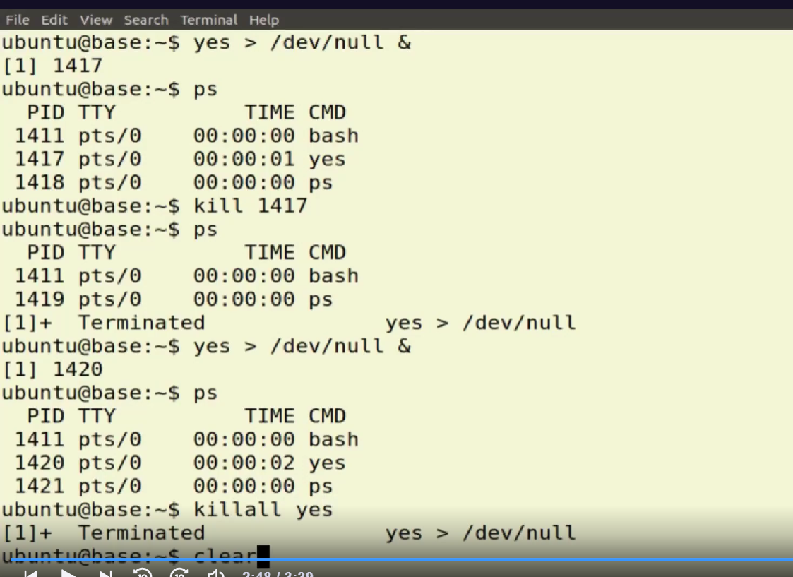

The Ampersand Operator (&)By appending the ampersand operator to any command, you dictate the shell to execute that Linux command in the background so that you can continue using the shell untethered.

I'll launch a process called yes that will output a text string to a kind of black hole called /dev/null. Any output sent to /dev/null will be instantly deleted, which makes it a harmless target for demos like this. I'll add the & character to tell Bash to run the process in the background, giving me back control of my command line. I'll confirm that's running by entering ps. Since this process exists within my current shell, it'll show up and tell me its process ID. I can use this number to kill off the process using, you guessed it, kill. The next time I send a command to the shell, it'll also display confirmation that the process was terminated. Let me run yes one more time. This time I'll kill it using the killall command and yes as its target. What's the difference between kill and killall? Kill will only operate on the process using that specific PID, while killall will, as the name suggests, kill all instances of yes running on a system.

What is the Linux kill command?

The kill command sends a signal to a process. This can terminate a process (the default), interrupt it, suspend it, crash it, and so on.

Killall terminate all precesses.

**sudo systemctl status apache2**

Checking Apache Server Status using systemctl Command  
  
Systemctl is a powerful command-line tool used to manage systemd system and service manager in Linux. It can also be used to check status of Apache web server.

The systemctl command manages both system and service configurations, enabling administrators to manage the OS and control the status of services. Further, systemctl is useful for troubleshooting and basic performance tuning.

To start a systemd service, executing instructions in the service's unit file, use the start command. If you are running as a non-root user, you will have to use sudo since this will affect the state of the operating system: sudo systemctl start application .service.

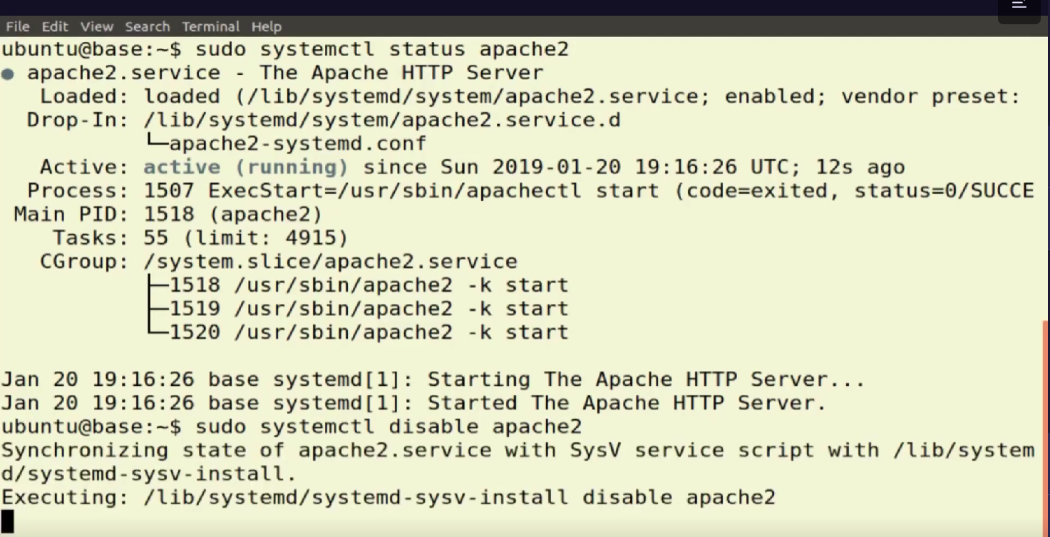

We can disable apache by disable command .

Refer : <https://www.digitalocean.com/community/tutorials/how-to-use-systemctl-to-manage-systemd-services-and-units>

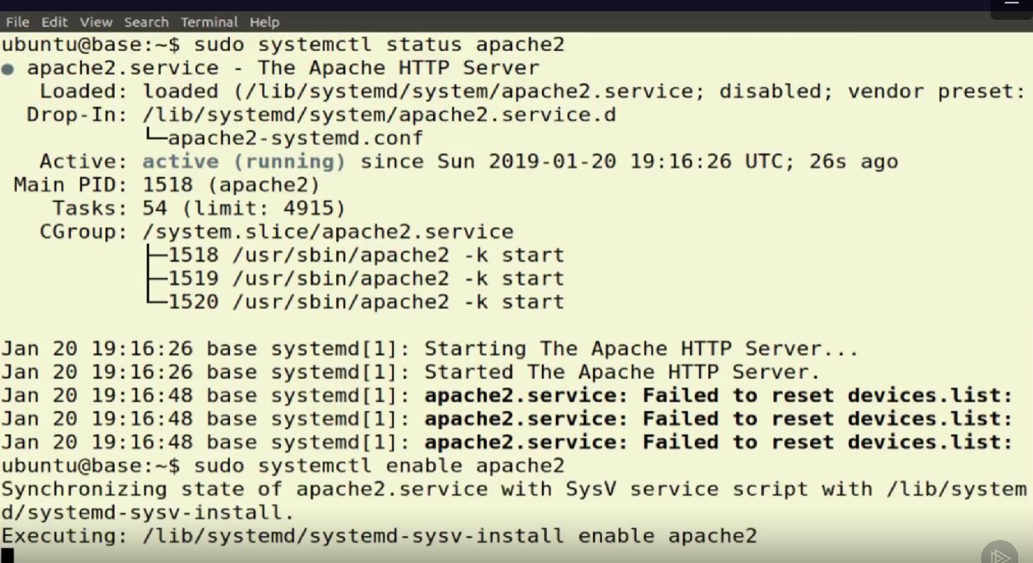

We again check the status of apache. We can see that apache is diabled , so we can start apache by enable command .

**Nice command**

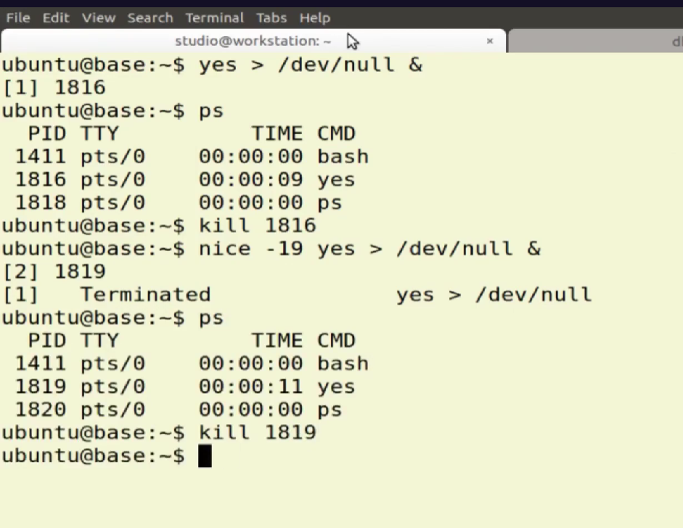

**nice command** in Linux helps in execution of a program/process with modified scheduling priority. It launches a process with a user-defined scheduling priority. In this, if we give a process a higher priority, then Kernel will allocate more CPU time to that process. Whereas the **renice command** allows you to change and modify the scheduling priority of an already running process. Linux Kernel schedules the process and allocates CPU time accordingly for each of them.

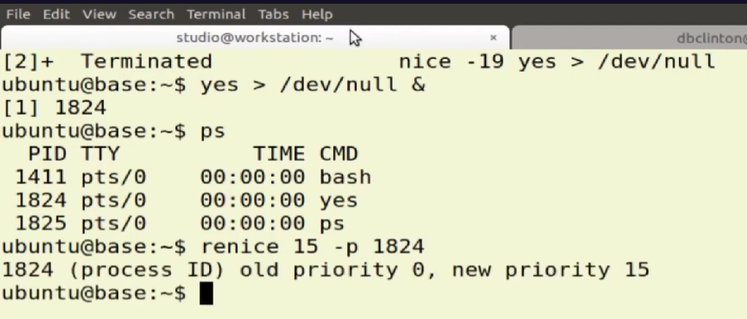

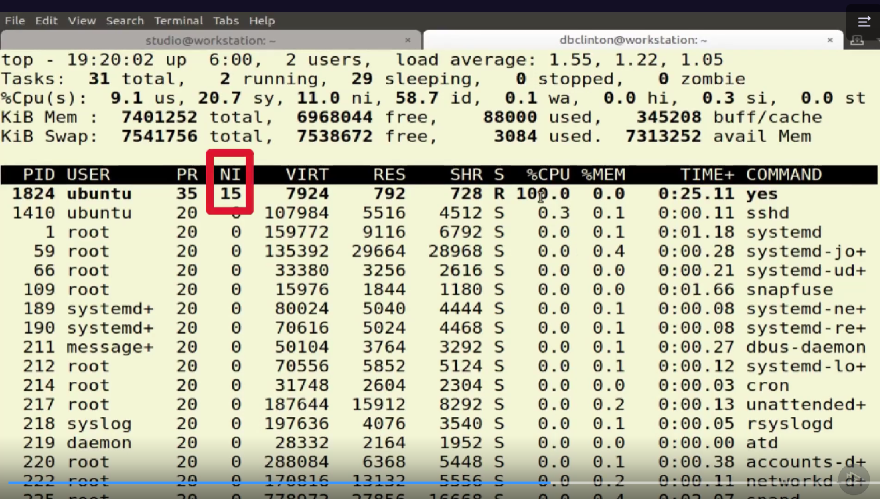

**Working with Users And Groups**

**Understanding Linux Users**

Anyone get any power via sudo. With sudo one can get admin power for sometime.

someone whose user account belongs to the sudo system group can invoke admin powers for just a single command. Once the command is executed, he automatically reverts to a regular user again.

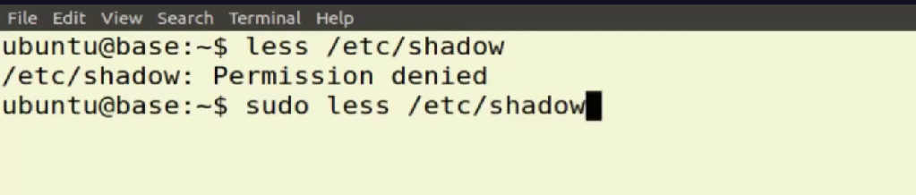

With sudo we can get the access to /etc/shadow .

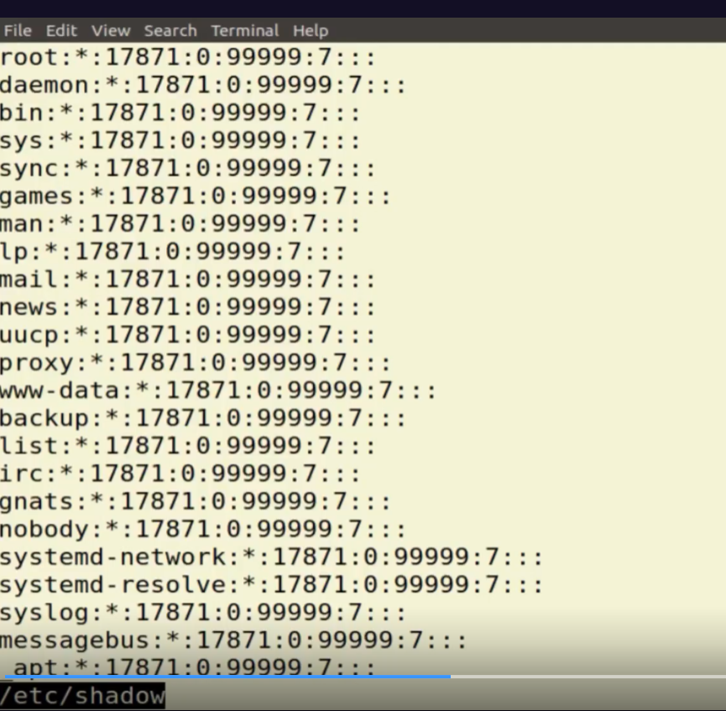

When I run a code with sudo , then I am admin user.i have get all privilages.

less /etc/passwd

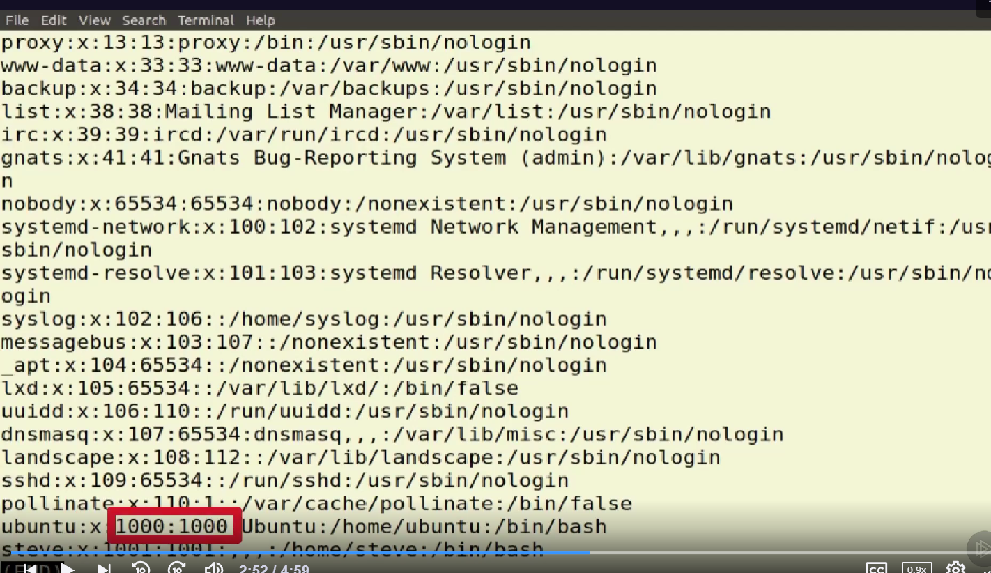

the first field ( ubuntu ) has the user's name. The X indicates the existence of a password in the shadow file. The next two numbers ( 1000:1000) are user ID and group ID numbers. The file system address is the location of the user's home directory ( ubuntu/home/ubuntu) , and /bin/bash is their default shell.

By the way, why are there so many users, and why do they seem to have such odd names like www‑data? These are system user accounts that exist to perform tasks on behalf of particular programs. The www‑data user will act as the face of the Apache HTTP server and access files and resources according to the rights it has been given. Unlike a regular user, www‑data won't have a home directory in the /home tree.

less /etc/group

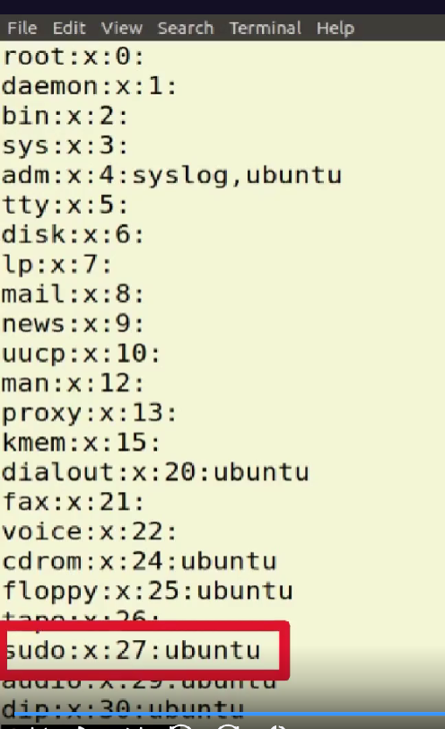

The next file we should see is group, which performs a similar function for groups containing the group name and group ID. Note how the Ubuntu user is the member of the sudo group. This is what allows that user to adopt admin powers when invoking sudo for a command.

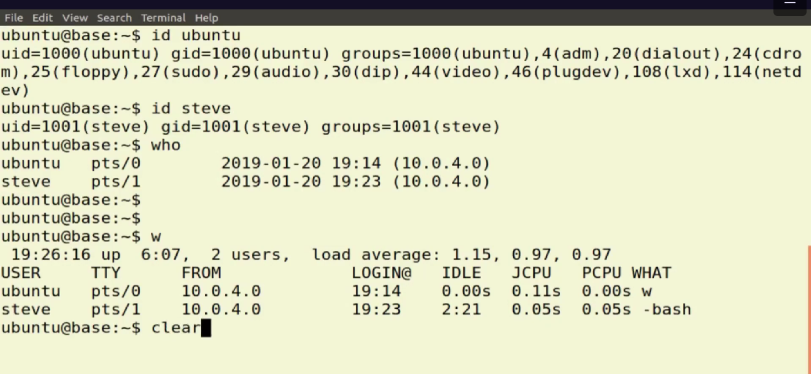

Id ubuntu and steve displays that what are the group ubuntu and steve are grouped.

Who display which are the users are currently loged in

W display details of users .

Who tells us which users are currently logged in, when their sessions began, and where they came from. If people start showing up at odd times, like the month after they were fired, for example, then it might be cause for alarm. The w command tells us not only who is logged in, but what they're currently doing.

last | less

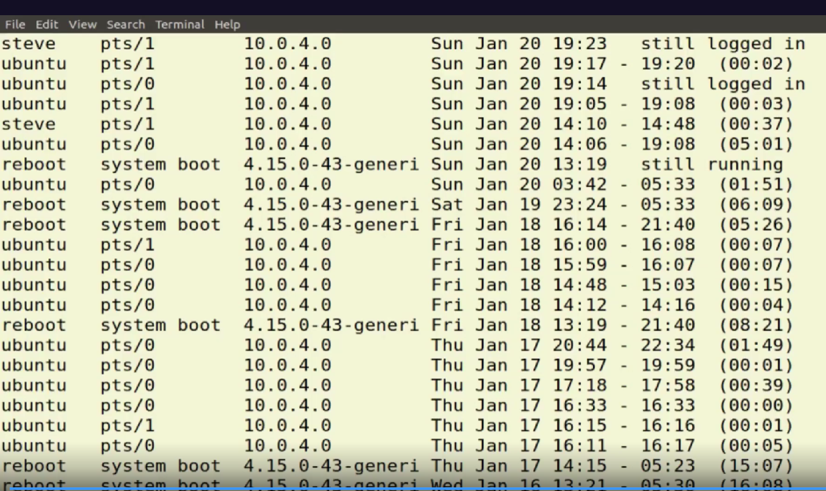

last gives you a list of all system logins since the beginning of the month.

**Administrating Users and Groups**

What is the useradd command in Linux?

useradd is a Linux command for creating a new user.

**‑m tells Linux to create a new directory in the home tree with the user's name.**

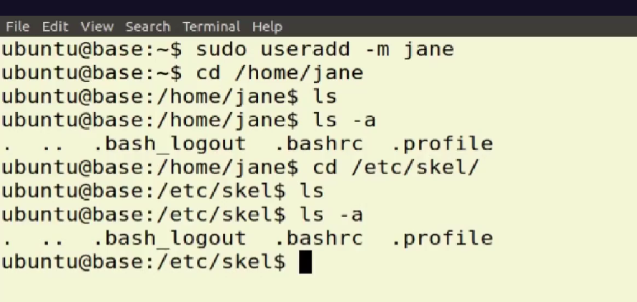

**Jane is added to home directory .**

**Using ls command we canot see the hidden files . ls -a command display hidden files .**

**Let's change directory to /etc/skel and run ls ‑a. This is known as the skeleton directory because it contains files or directories you'd like to form the skeleton or base of the home directory of new users as their new accounts are created. I could, for instance, save a file listing the locations of our application resources within the file system to scale, and it would automatically appear in all new users' home directories. If you've been following closely, and I'm sure you have, you will probably be wondering how Jane will log in to her new account considering she has no password. In fact**

**How jane will login her new account**

**, I'll have to use my sudo powers to do that for her. I run sudo passwd, not password, and the new username and then create a temporary password. Once Jane has logged in for the first time with this password, she can run passwd for herself without sudo to create a new, permanent password for herself.**

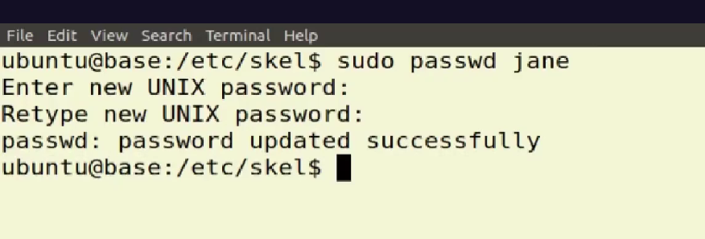

**We can limit user’s system access to some resources . we want to allow some users to grant acces to some resources , then we create a group , add users to that group and that give that group to access the some resourses.**

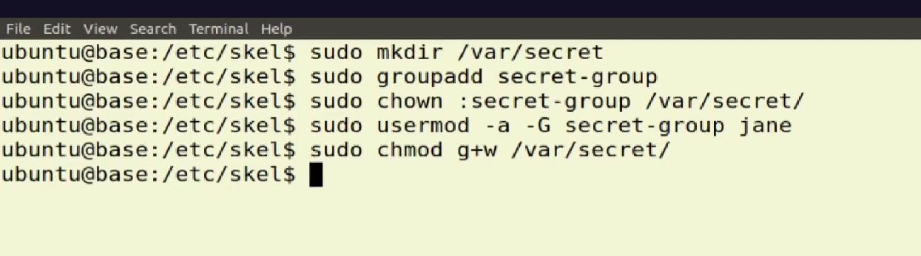

**Let's say we've got some highly sensitive top secret documents in a directory called /var/secret. Using groupadd, I'll create a new group that, being the creative guy I am, I'll call secret‑group. Now I'm going to use a program called chown to change the ownership properties of the /var/secret directory. Now I could add, say, Jane to the secret‑group, and she'll have full power over all the contents of that directory. One way to do that is through usermod. ‑a means add, and ‑G means to an existing group. We then type the group name, followed by the username, and we're nearly done. All that's left is to edit the permissions for the secret directory to allow group members to edit files. This we do with chmod. G+w means that we'll add write permissions for members of the directory's group. Jane can now do whatever she feels is necessary on all of the contents of the secret directory.**

**SECURING YOUR LINUX SERVER**

**Appling Object Permissions**

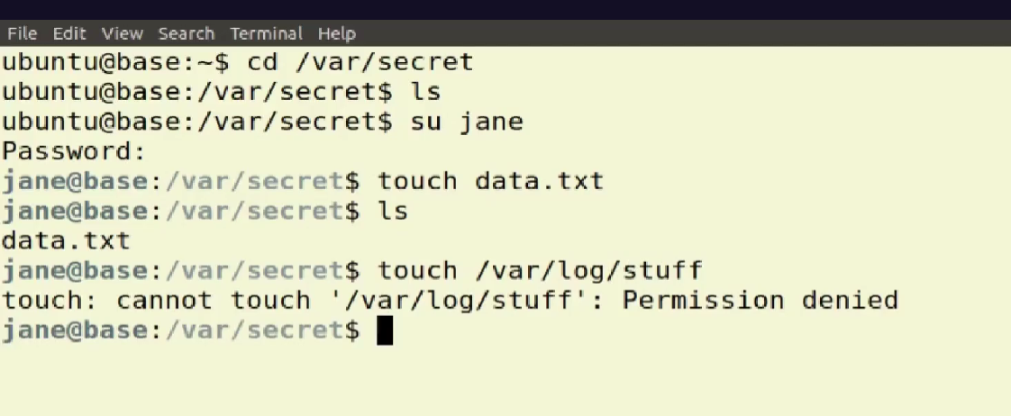

Jane has no aacess in stuff directory , so jane has not right to create a file in stuff directory . jane has access to secret so jane has permission to create a file secret directory .

Su means allows a user to switch to another user account and gain all of its privileges, while sudo command in linux allows a user to execute a specific command with the privileges of another user.

ls -l. The -l option signifies the long list format. This shows a lot more information presented to the user than the standard command. You will see the file permissions, the number of links, owner name, owner group, file size, time of last modification, and the file or directory name.

refer : <https://www.hostinger.in/tutorials/linux-commands>

ls-dl

this will display attribute not the content , but of the secret directory itself .

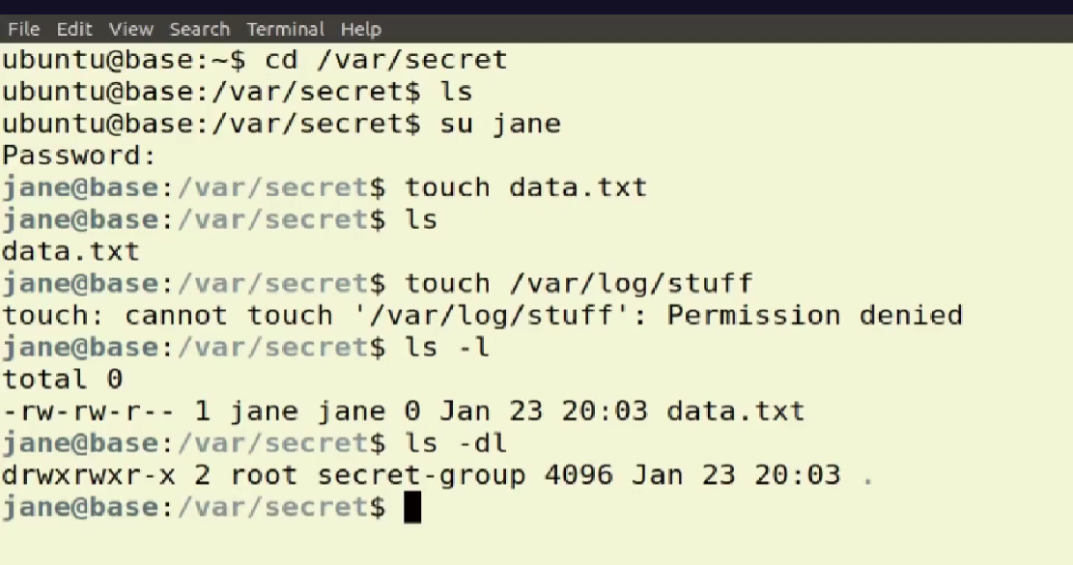

* rw- rw- r-- this is made up of 4 groups , the first – indicates directory , rwx means read , write , execute the first rwx means if the object’s owner can use the file ,here the owner can read and write and not execute.

The next three characters represent the permissions of members in the owning group, Jane's group in this case. All group members will have both read and write authority, but not execute. The final cluster of three characters represents the rights of all other non‑root users. They can read but not write or execute. The next field tells us that the file owner is Jane and its group is jane. Even though the directory is owned by root, the file is Jane's because she's the one who created it. Now let's look at the directory's attributes. We already mentioned the d for directory, but we can also see how both the owner and group have full rights, read, write, and execute. Others will be able to read and execute, but not write.

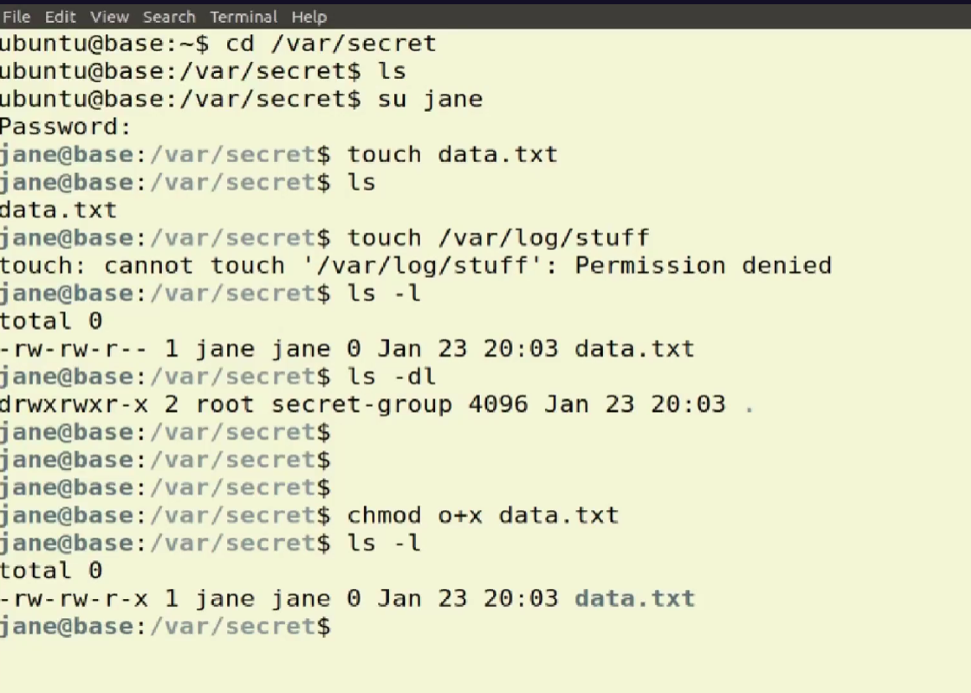

Why, though, is the directory owned by root? Because it was created using sudo, which is effectively acting as root. The chown operation I ran a while back changed only the group, but not the owner. To do that, I would've included some value like my own user name before the colon and then secret‑group after the colon to set the group.

What is chmod command in Linux?

Linux chmod command is used to change the access permissions of files and directories. It stands for change mode. It can not change the permission of symbolic links. Even, it ignores the symbolic links come across recursive directory traversal.

Chmod o+x data.txt

Means the others have given the power of execute to data.txt

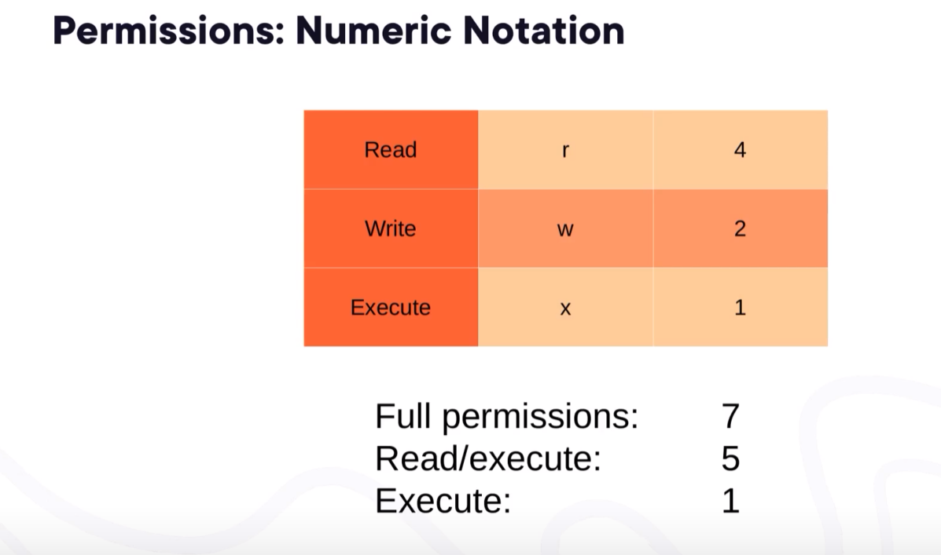

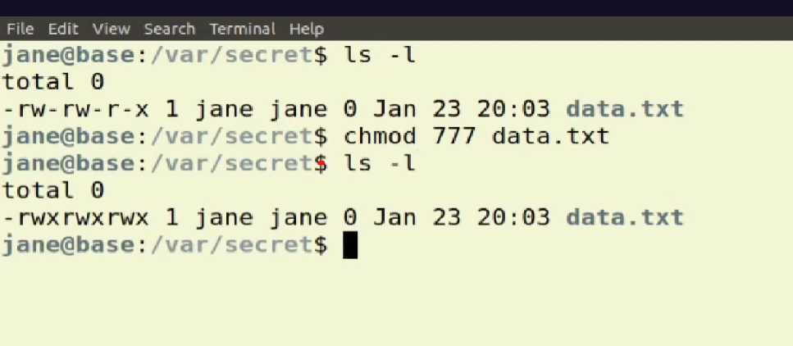

We can add read, write , execute power by numbers .

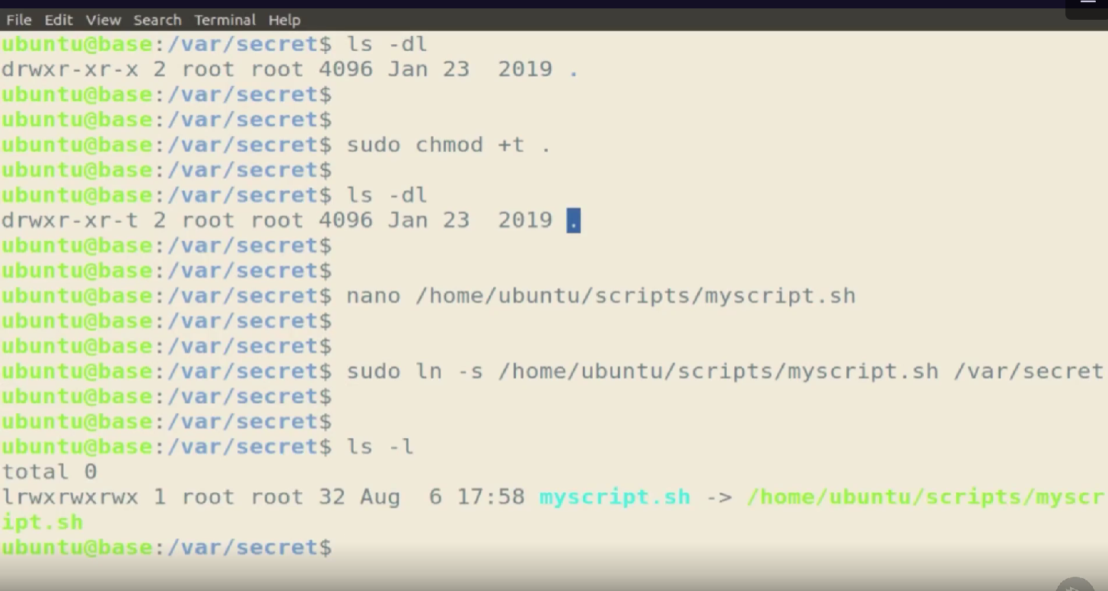

The sticky bit is a permission bit that protects the files within a directory. If the directory has the sticky bit set, a file can be deleted only by the file owner, the directory owner, or by a privileged user. The root user and the Primary Administrator role are examples of privileged users.

Sticky Bit Special Permissions

You can only assign the sticky bit by explicitly defining permissions. The character for the sticky bit is t. To set the sticky bit on a directory named dir1 you would issue the command chmod +t dir1.

A symlink is a symbolic Linux/ UNIX link that points to another file or folder on your computer, or a connected file system. This is similar to a Windows shortcut. Symlinks can take two forms: Soft links are similar to shortcuts, and can point to another file or directory in any file system.

Nano is a text editor .

Ln -s is to create symbolic link.

We created a nano editor named as myscript.sh at script folder .This nano editor created as symbolic link at /var/secret directory .when we are on the /var/secret directory then we can go to nano editor .

A port in Linux is a virtual concept that helps in accessing different services within a network. It is a 16-bit integer ranging from 0 to 65535 with no physical existence. A port, when combined with an IP address, results in a socket address that is used to establish a connection between the client and the server.

Service Access Controls

What is service hardening?

Server hardening is a type of system hardening process that aims to protect and secure a server against cyberattacks by reducing its attack surface. An attack surface consists of all possible points of a system where an unauthorized attacker can attempt to enter.

Port control

Within an operating system, a port is opened or closed to data packets for specific processes or network services. Typically, ports identify a specific network service assigned to them. This can be changed by manually configuring the service to use a different port, but in general, the defaults can be used.

Firewall Rules

Firewalls create a barrier between a trusted network and an untrusted network. Firewalls work by defining rules that govern both authorised and blocked traffic. The firewall utility developed for Linux systems is iptables. Find out how to secure a dedicated server with iptables.

A port is an addressable network location implemented in an [operating system](https://www.linuxandubuntu.com/home/category/distros) to help differentiate traffic destined for different services or [applications](https://www.linuxandubuntu.com/home/50-essential-linux-applications). A port is always associated with an IP address of a host and the protocol type for the communication.

<https://www.linuxandubuntu.com/home/what-are-ports-how-to-find-open-ports-in-linux#google_vignette>.

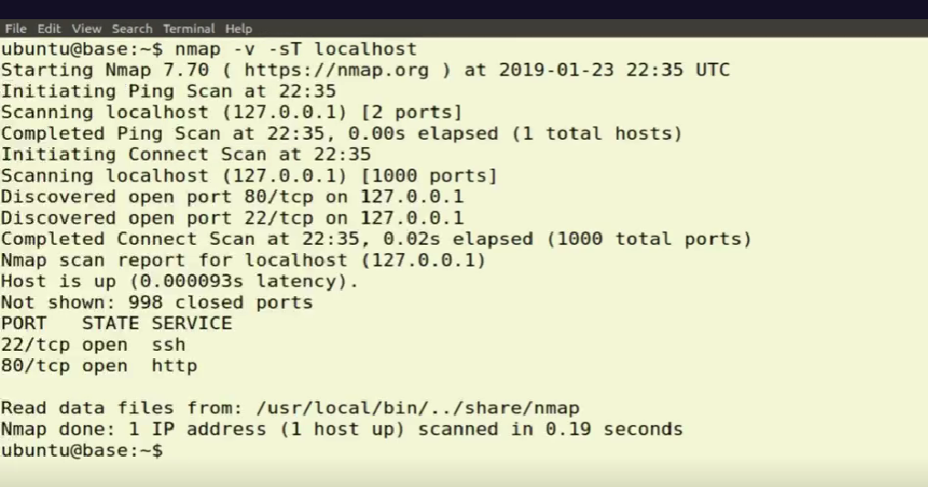

**Nmap** is Linux command-line tool for network exploration and security auditing. This tool is generally used by hackers and cybersecurity enthusiasts and even by network and system administrators. It is used for the following purposes:

* Real time information of a network
* Detailed information of all the IPs activated on your network
* Number of ports open in a network
* Provide the list of live hosts
* Port, OS and Host scanning

-v :It is used to get more detailed information about the remote machines.

The systemctl command manages both system and service configurations, enabling administrators to manage the OS and control the status of services. Further, systemctl is useful for troubleshooting and basic performance tuning .

Nmap is a powerful and complicated tool, but let me give you just two simple examples that'll give you most of what you need right now. Running nmap with ‑v for verbose and ‑sT, which will scan using the TCP protocol, followed by localhost, will scan your own computer for open ports. This operation on one of my own computers found two open ports, 22 for SSH and 80 for insecure HTTP web pages.

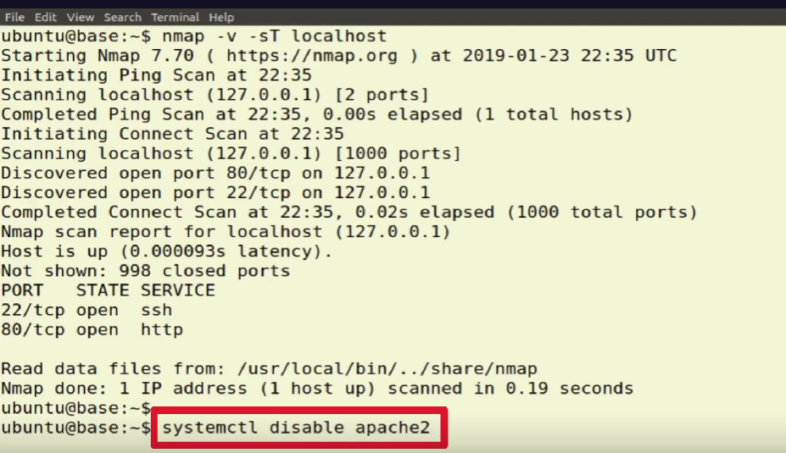

I didn't want to accept requests on port 80, I would simply stop and disable my web server using systemctl.

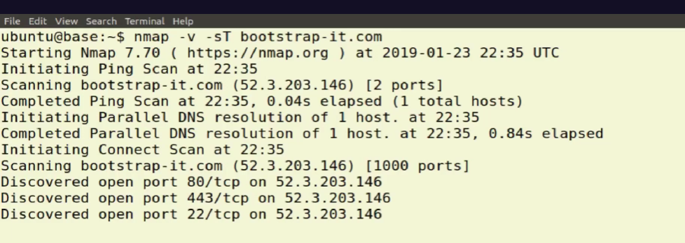

Running the exact same nmap command, but against an external address like my bootstrap‑it website will show me what's currently visible on that server from the network. This one also accepts secure HTTP requests through 443 .

Data Encription

You create your digital data so that you, along with friends, colleagues, and customers, can consume it. That means it's got to to be in a format that's readable. But at the same time, you'll want to prevent the wrong people accessing your private correspondence and business data. The best way to make sure those wrong people can't read your stuff is by converting it to meaningless gibberish through encryption. Authorized users will use some kind of shared decryption key, perhaps a key pair, session token, or password, to unlock the encryption when necessary. Where might you apply encryption? Mobile devices like smartphones and laptops are generally good candidates since they often contain sensitive data, but are always at risk of being stolen or lost. Since you don't want whoever ends up with your phone to be able to just power it up and effectively own everything on it, you might want to encrypt the entire drive. Linux distributions will usually offer you option of encrypting a drive during the installation process, but you can always add encryption later. Either way, you need to provide a strong passphrase with which you'll authenticate to gain access for yourself. ECryptfs is a popular tool for encrypting individual files or directories, and cryptsetup is great for encrypting entire volumes.

What is SSL and TLS certificates?

SSL/TLS stands for secure sockets layer and transport layer security. It is a protocol or communication rule that allows computer systems to talk to each other on the internet safely. SSL/TLS certificates allow web browsers to identify and establish encrypted network connections to web sites using the SSL/TLS protocol.

***WORKING WITH DOCKER AND LINUX CONTAINERS***

Server virtulization share the resourses of a single physical server among multiple running os.

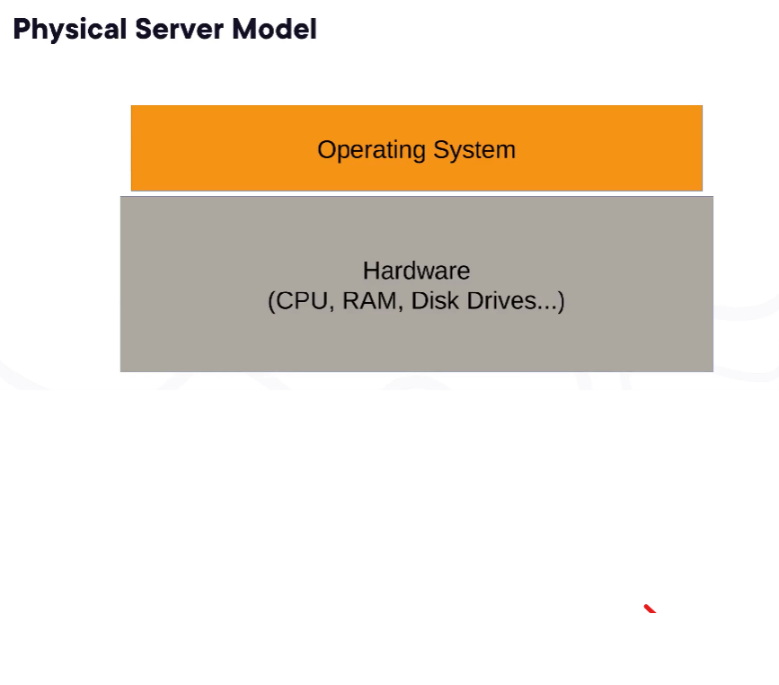

Once we buy a system we use the system when the system will damage . Up to that time we can use diff OS.

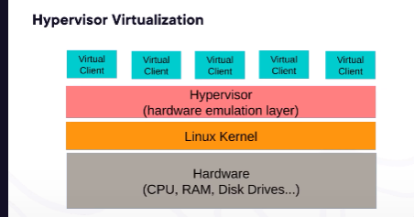

This is virtual computer , in this diff os are placed at the same time , we cannot bother about hardware , all that wht we want that provided by cloud .

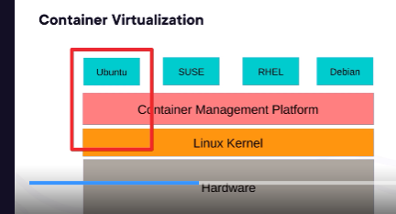

A container is built to share a single kernel with its host, meaning that the core of the container itself might take up only 30 or 40,000 bytes of disk space.

number of container instances that can concurrently run on a single server is limited only by available resources.

There are just too many variables to expect things to just work out of the box.

**Docker ecosystem**

It's a central place where containers are deployed – an abstraction from running applications. A Docker server is referred to as a “host,” and each application container running on the host is called a “container”. Multiple containers can run concurrently on a single host.

A Docker image is a file used to execute code in a Docker container. Docker images act as a set of instructions to build a Docker container, like a template. Docker images also act as the starting point when using Docker. An image is comparable to a snapshot in virtual machine (VM) environments.

One way to define or customize your own image is by writing a Dockerfile, which is a simple text script that declares the components and configuration environment you want for your image.

<https://docs.docker.com/engine/reference/builder/>

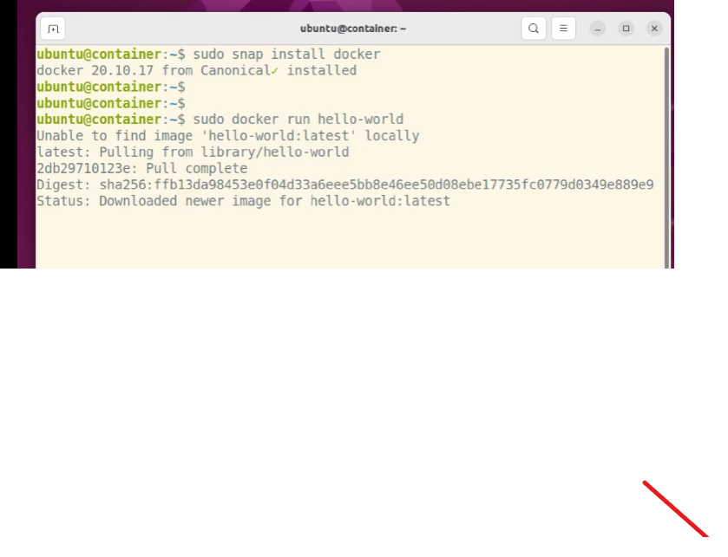

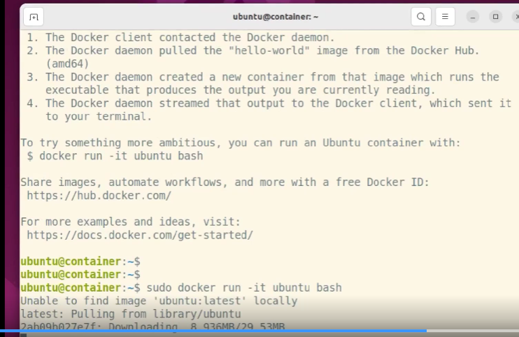

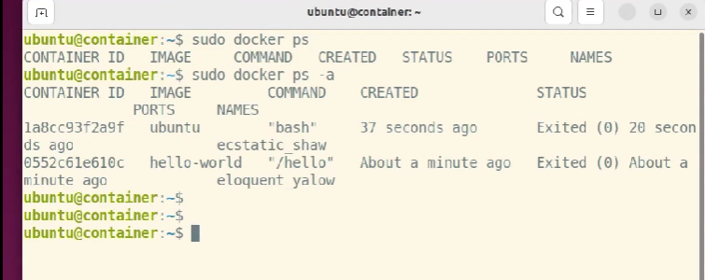

Ps : provide currently running images

Ps a: provide all images

***Building a Customized Docker Image***

In this final demo, we're going to do two things, create a Dockerfile script to build a new Docker image that'll include a simple Apache web server and then push our new image up to my own image repository on Docker Hub. Let's get it done. I'll paste these script contents into a file call Dockerfile. Make sure you use uppercase for the D. You can, by the way, copy and paste this Dockerfile from the course web page at bootstrap‑it.com/linux‑admin.

What is Docker container and why it is used?

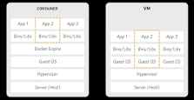

Docker lets you build, test, and deploy applications quickly  
  
Docker packages software into standardized units called containers that have everything the software needs to run including libraries, system tools, code, and runtime.

What is a Docker container example?

An example: a website, API and database have to be connected together. This is what Docker Compose allows us to do. We can create a file that defines how containers are connected with one another. We can use this file to instantiate all of the Dockerfiles for all of our containers all at once!

Nano dockerfile

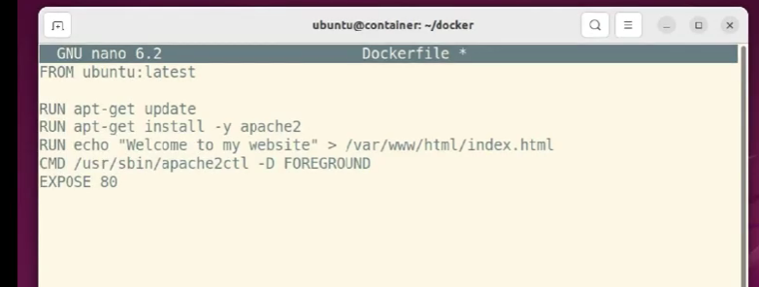

The action begins with the FROM line, which sets the latest version of Ubuntu as our base image, on top of which we'll create our custom image. The RUN lines are just regular Bash commands we want to use to build our image. In this case, obviously, we're updating the local repo index and then installing the Apache HTTP server. Note how we use the older apt‑get command rather than apt. That's because apt‑get is more reliable in scripted settings. The ‑y will automatically answer yes whenever we're asked. If you didn't do this, you would have to find a way to manually enter our responses, or, more likely, the operations would just fail. The echo command will take the text enclosed by quotation marks and use it to replace the existing contents of the index.html file that Apache will have placed in the web root directory /var/www/html. CMD will run this command within our Linux system that'll make sure that Apache is up and running and accessible to external requests. Finally, EXPOSE 80 tells Docker to open port 80 into the container to network requests. That's how our website users will access the site's pages.

A Dockerfile is basically a text document that contains all the commands a user could call on the command line to assemble an image. The Docker platform runs natively on Linux and allows developers to build and run containers, self-contained applications or systems with no dependencies on the underlying infrastructure.

What does sudo docker build do?

The docker build command builds Docker images from a Dockerfile and a "context". A build's context is the set of files located in the specified PATH or URL . The build process can refer to any of the files in the context.

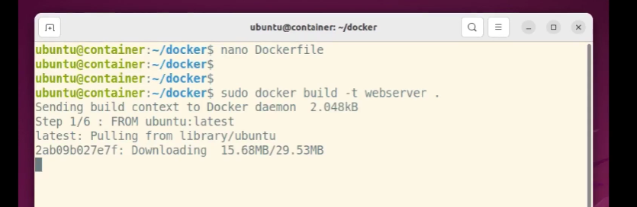

The ‑t will specify the naming tag, webserver in this case, we want to attach to this image. The final dot tells docker build to look for a Dockerfile in the current directory.

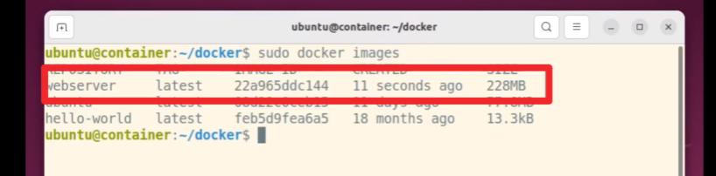

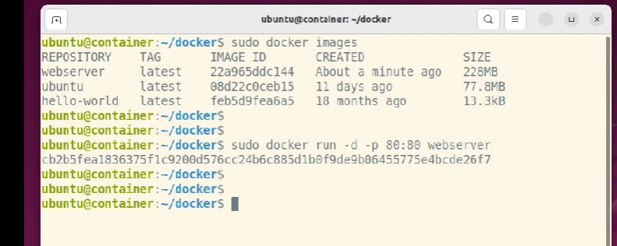

I'll fire up a container based on the webserver image using docker run. ‑d tells Docker to remain detached from the container, meaning we don't want to open a shell session inside. ‑p will permit incoming traffic from my host network on port 80 and through port 80 to the container. We're showing a rather long and nasty ID string through which we can deduce that our container is running, but is the web server inside really operational? Let's find out.

What is curl command used for in Linux?

curl is a command-line tool to transfer data to or from a server, using any of the supported protocols (HTTP, FTP, IMAP, POP3, SCP, SFTP, SMTP, TFTP, TELNET, LDAP, or FILE). curl is powered by Libcurl. This tool is preferred for automation since it is designed to work without user interaction.

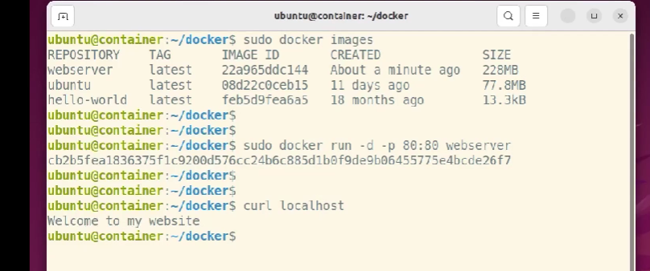

From the host machine, I'll run curl against localhost, and there's our lovingly handcrafted index.html page.



but what about from outside the Docker host machine? Can we open this web page from the network? Why not find out? I'll use the IP address of the virtual host VM from my workstation's browser.

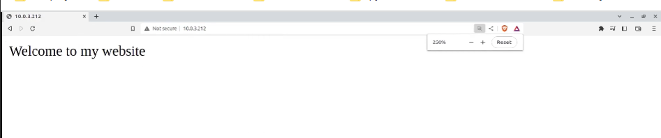

Bingo, we're in. The cool thing is that I put together this simple web server without setting foot inside the container itself. Everything happened in the Dockerfile script.

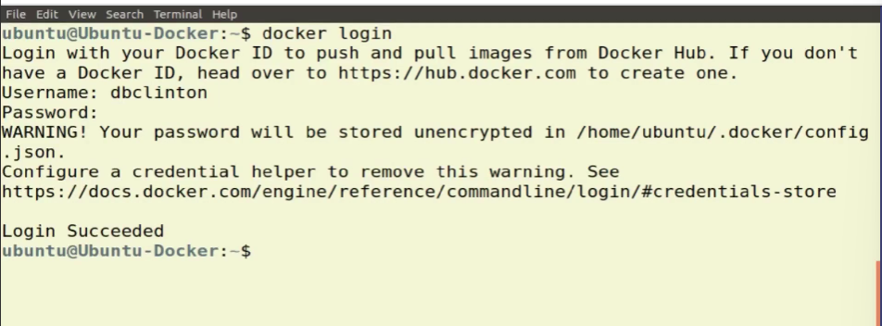

If I would want to share my new image with my closest friends and colleagues, I could push it to a repo in my Docker Hub account. First, though, I'll log in to my account from the command line using the Docker login credentials I created when I open my account on the Docker Hub website. Now we're connected, I'll show you how to search for an existing public image you can download and use.

I'll look for images built out of the Nextcloud data storage and file sharing platform.

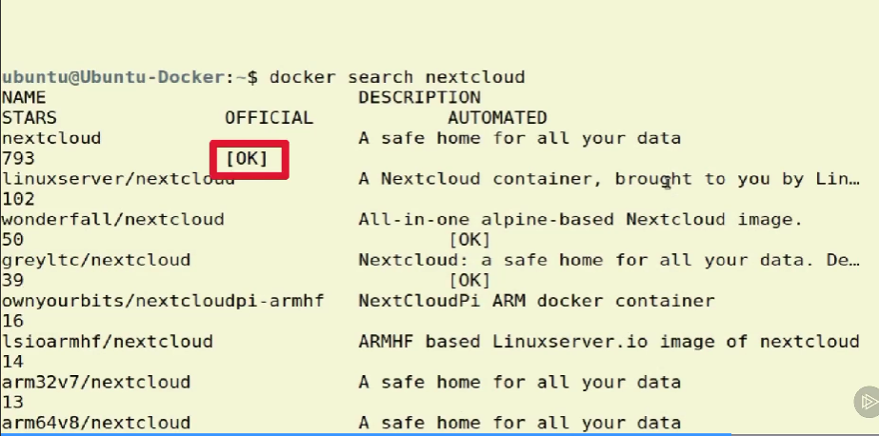

If I scroll back up through the results, which are kind of hard to read at this resolution, I'll see the first image displays an OK for supported and has nearly 800 vote stars. This suggests that this image is probably your best bet.

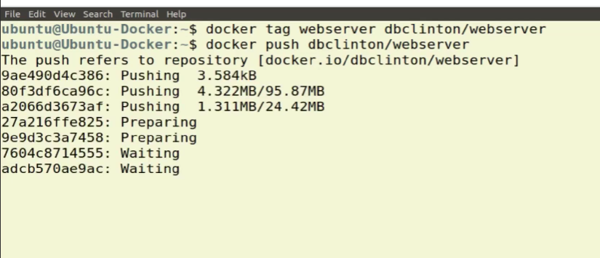

I could download the image using docker pull, like this, but that's not what we're after right now. What we are after is figuring out how to push our webserver image up to Docker Hub. Before I can push the image, I'll need to add an identifying tag. Predictably, that'll take the docker tag command where I give the dbclinton/webserver tag to the webserver image. With that done, I can send the image on its merry way using docker push, followed by the tag. The first part of the tag is the name of my Docker Hub account, which, by default, Docker will always assume as a target.

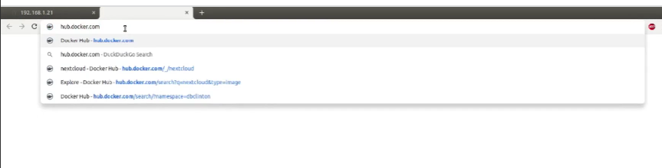

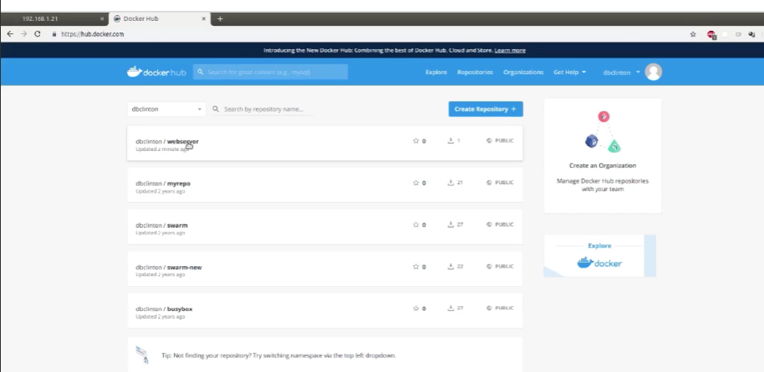

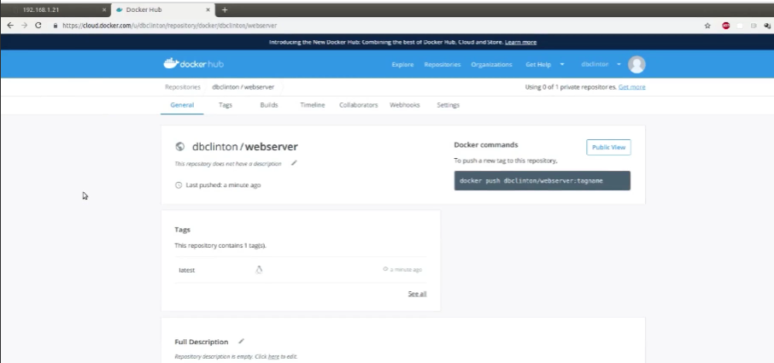

Naturally, you can point your push operations to any other repositories you may be using, including local repos. Let's just check into my Docker Hub page to confirm that the new image is indeed where we put it.